10/1/2022
Soka Zimba
ZCAS UNIVERSITY

MICROSOFT TEAMS’ STEP BY STEP GUIDE

Table of Contents
1. Meeting recording storage and permissions 2
1.2 Share a link to a meeting recording with others 2
1.3 Option 2: EASY STEPS 5
2. VIEW AND DOWNLOAD MEETING ATTENDANCE REPORTS IN TEAMS 5
2.1 During the meeting 5
2.1.1 After the meeting 6
2.2 In the meeting invite 6
2.3 In the meeting chat 8
Scheduled channel meetings 9
2.4 Known issues and limitations 9

Meeting recording storage and permissions
To access the recordings, log in to Office 365. Click this link: https://www.office.com/?from=Homescreen. When you login, click App Launch, which has nine dots on the top left of your screen, and you will see the apps as highlighted in the figure below. Teams meeting recordings will be stored in OneDrive or SharePoint, depending on the type of meeting.

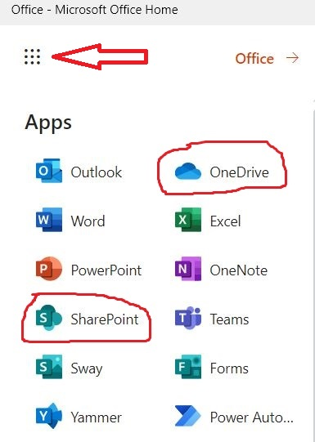
Note that a recording will expire and be automatically deleted after a set period of time. The amount of time it's available is set by your admin, but you can change or remove the expiration date of any given recording.

Share a link to a meeting recording with others
If you recorded or organized the meeting, you can share the recording with people who weren't invited to the meeting—by just sharing it like you would share any other file.

Just find the file in OneDrive or SharePoint and share it directly with people or copy a link and share it whoever you like. You click share as it is shown with the arrow in red on the screen. After of you have clicked the share button, send link menu appears which shows copy Link.
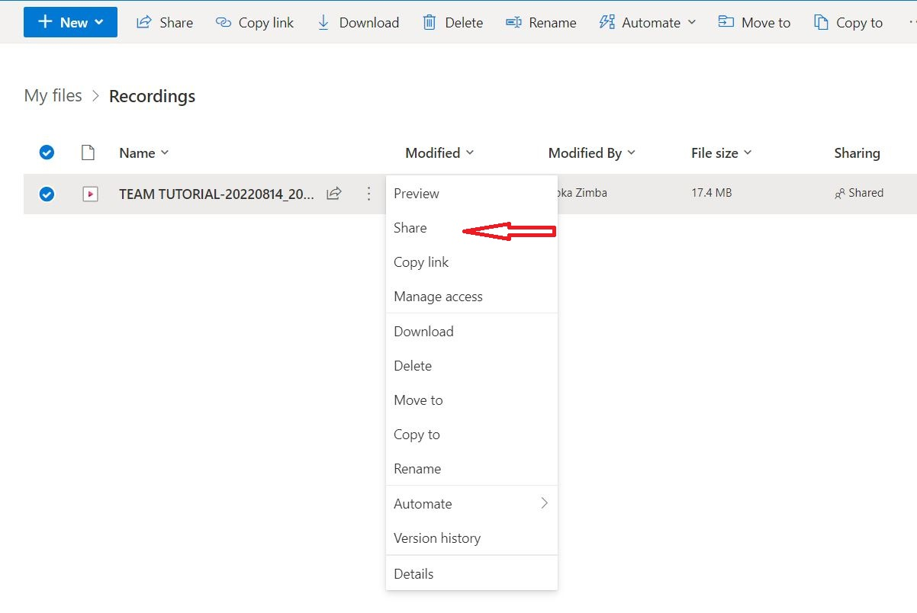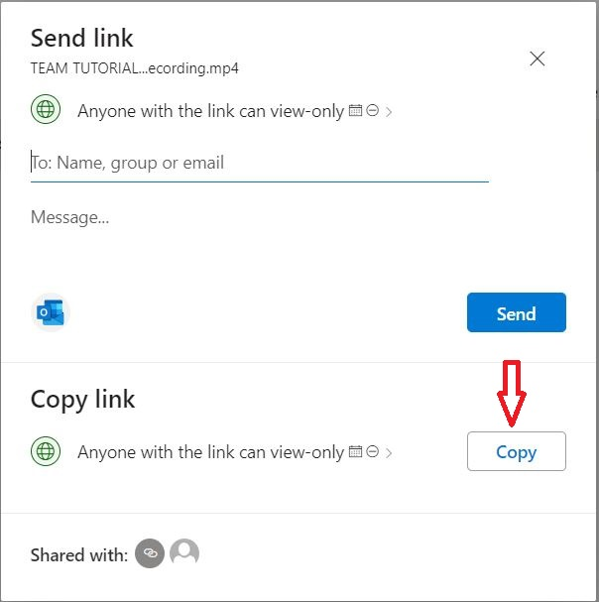
You can also copy it by clicking the arrow at the end of "Anyone with the link can view-only > as shown above. The link settings will display the following screen as shown below.
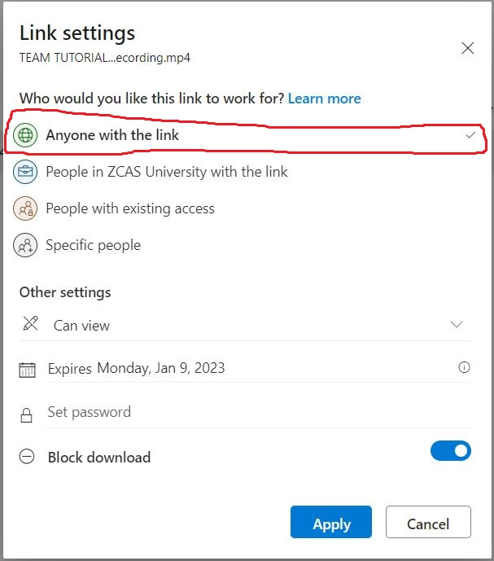

The highlighted of Anyone with the link is ticked which means anyone with the link can view. You then click “Apply” and the link is generated and you copy the link and add it on the portal for the students to have access to the videos.
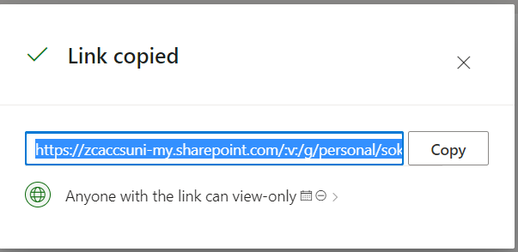

Option 2: EASY STEPS
There are 2 ways to share a recording, the first one is where you share the link with whoever you want, and the second one is that whoever has the link can see the recording.
- Go to the OneDrive website and sign in with your Microsoft account or your work or school account.
- Pick the files or folders you want to share by selecting its circle icon.
- Select Share icon at the top of the page.
- Under Copy Link, select Anyone with the link can edit to open the link settings.
- To change the link permissions, select an option for who you want to give access to with the link:
- Once you have set all your link settings and permissions, select Apply.
- Under Copy link, select Copy.
- Paste the link and send the link where you want to send it, like an email, message, or post.

Here is the link to the official Microsoft website where I found this information, you can refer to this link if you want to see the screenshots of the step:
https://support.microsoft.com/en-us/office/share-onedrive-files-and-folders-9fcc2f7d-de0c-4cec-93b0-a82024800c07.

VIEW AND DOWNLOAD MEETING ATTENDANCE REPORTS IN TEAMS
If you've organized a Teams meeting, you can download a current attendance report during the meeting as well as a final report after the meeting. The report includes the name of each person in the meeting and the time they joined and left.

During the meeting
- If the participants pane isn’t open, select People in your meeting controls.
- Click More actions, then select the Download attendance list to download the current attendance info as a .CSV file that you can open in Excel.
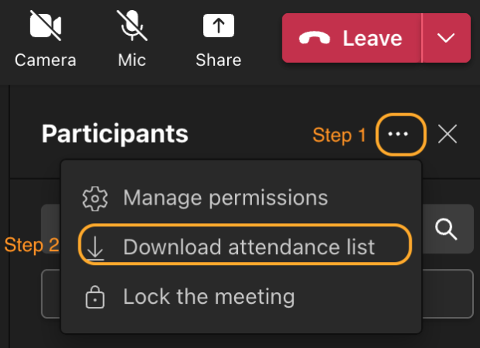
Look for the file in your device's Downloads folder.

After the meeting
You'll find the attendance report in a few different places.

In the meeting invite
In Teams, go to Calendar , open the meeting, and select the Attendance tab. You can view the data directly in Teams.
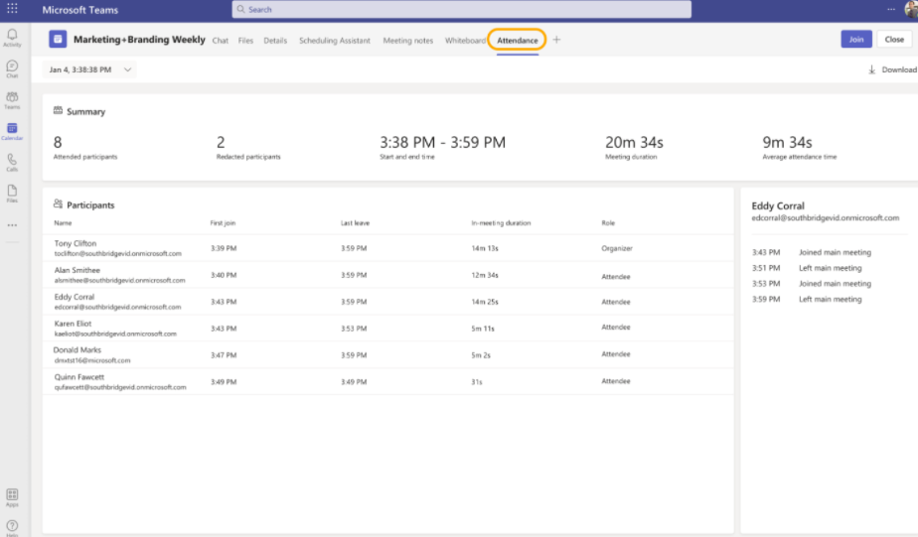
For recurring meetings, select the report you want to view from the dropdown list.
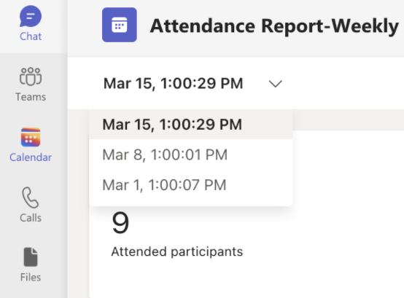

To download the attendance .CSV file for the meeting, click Download:
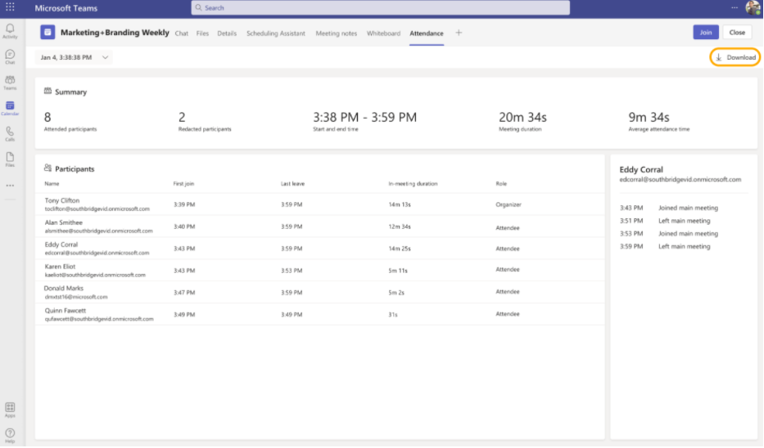
Note: If you set up breakout rooms in your meetings, the attendance information will be shown in main meeting’s attendance reports.

In the meeting chat
A tile labelled Attendance report will pop into the chat about five minutes after your meeting ends. Select it to download the .CSV file.
Note: For recurring meetings, you'll receive a unique attendance report after each occurrence.
You can also view attendance information in the Attendance tab in the meeting or webinar chats:
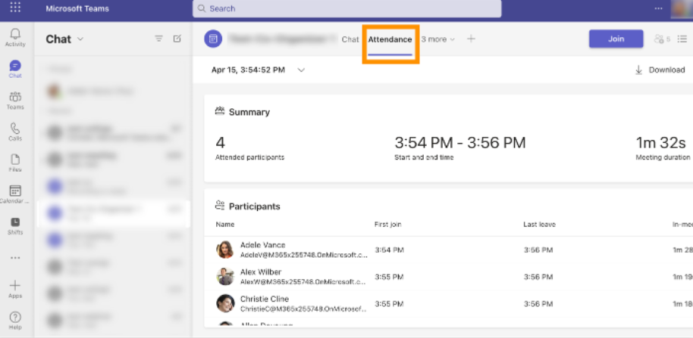

Scheduled channel meetings
To view the attendance reports for meetings created in channels, click the three dots icon > View meeting details then navigate to the Attendance tab.
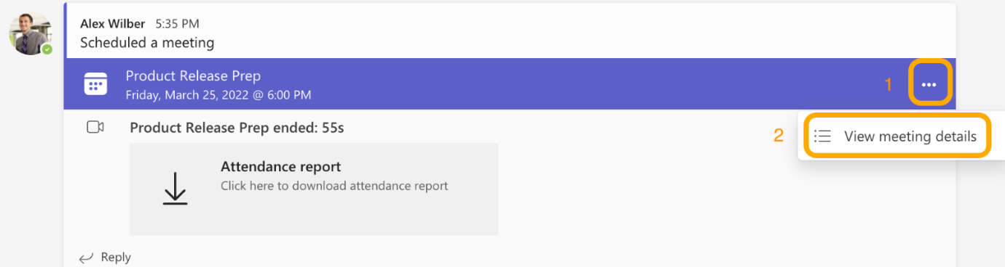
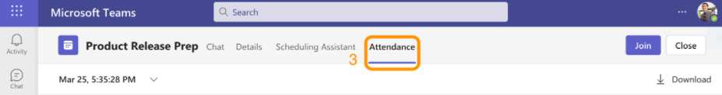

Known issues and limitations
- In meetings with more than 120 participants, the attendance report that's available during the meeting will only include a partial list of attendees. The post-meeting report will contain the full list.
- The report does not include insights from deleted breakout rooms.
- The report does not currently include view-only attendees.
- If a channel meeting is in progress and someone starts a second meeting within the same channel conversation, an attendance report will be available only for the second meeting. You can go to the Attendance tab in the Teams calendar invite for all channel meeting attendance reports.
- If someone waits in the lobby and doesn't get admitted to the meeting, they won't be included in the report.
- When a participant is on hold in a meeting, their info is still included for this period of time in attendance report.

Reference
- https://support.microsoft.com/en-us/office/play-and-share-a-meeting-recording-in-teams-7d7e5dc5-9ae4-4b94-8589-27496037e8fa#bkmk_sharelinkmeetingrecording.
- https://support.microsoft.com/en-us/office/view-and-download-meeting-attendance-reports-in-teams-ae7cf170-530c-47d3-84c1-3aedac74d310#:~:text=In%20the%20meeting%20invite&text=%2C%20open%20the%20meeting%2C%20and%20select,view%20from%20the%20dropdown%20list.
- https://support.microsoft.com/en-us/office/share-onedrive-files-and-folders-9fcc2f7d-de0c-4cec-93b0-a82024800c07.

