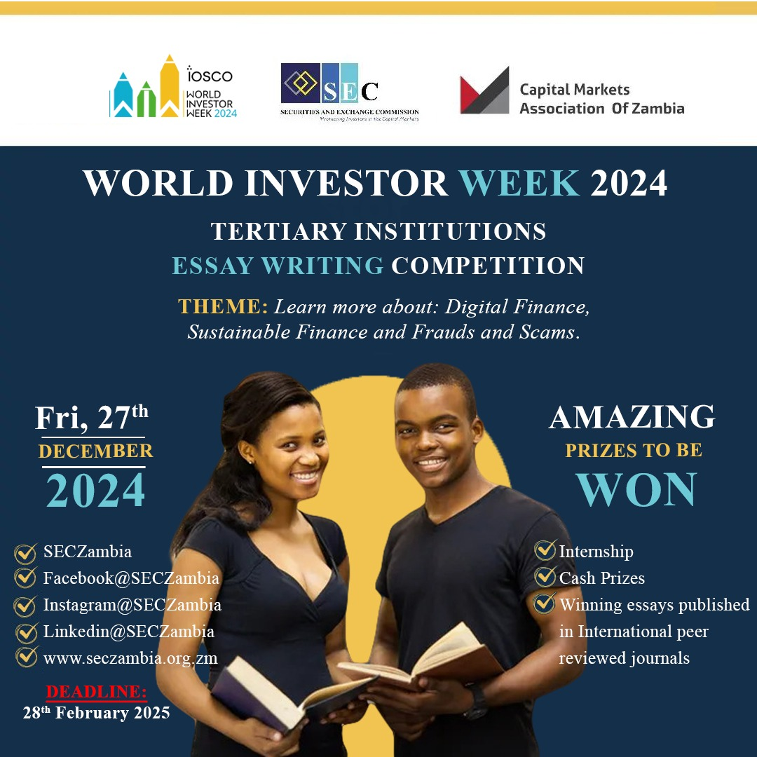

ALLING ALL STUDENTS IN TERTIARY INSTITUTIONS! 📚✍

The Securities and Exchange Commission (SEC), in partnership with the Capital Markets Association of Zambia, invites you to participate in the 2024 World Investor Week Essay Writing Competition.

Prizes:

🏆 1st Prize: K10,000 + Certificate + Internship

🥈 2nd Prize: K7,500 + Certificate + Internship

🥉 3rd Prize: K5,500 + Certificate + Internship

Submission Deadline: 28th February 2025, 24:00hrs.

Eligibility: Open to all students in registered Zambian tertiary institutions.