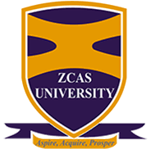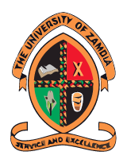
NOTICE
TO: GRADUANDS ON THE UNIVERSITY OF ZAMBIA/ ZCAS UNIVERSITY MOU PROGRAMMES
FROM: THE ACADEMIC AFFAIRS MANAGER
DATE: 19TH FEBRUARY 2023
SUBJECT: 53RD UNIVERSITY OF ZAMBIA GRADUATION CEREMONY

Refer to the above caption.
This serves to inform you that the University of Zambia has scheduled its 53rd Graduation Ceremony from Monday, 20th to Friday, 24th May 2024. You are hereby requested to carry out the final clearance procedure with ZCAS University as follows:
- Fulfil all financial obligations to the University.
- Obtain a clearance from Student Administration Office then proceed to clear with respective Schools and units.
- Submit a copy of your clearance and confirm your details and participation with ZCAS University Examinations Office or call on +260211222508 or +260979128798 by Friday 29th March 2024.
Thereafter, proceed to pay ZMW400.00 participation fee either by card swiping at the University of Zambia Academic Affairs Accounts Office Room 2 or Bank Deposit using the following bank details:
ZAMBIAN NATIONAL COMMERCIAL BANK (ZANACO)
UNZA REGISTRAR'S DEPARTMENT
0306506302182
UNZA AGENCY

STANDARD CHARTERED BANK ZAMBIA
UNZA REGISTRAR'S DEPARTMENT
0100110273800
BRANCH CODE: 0617
MAIN BRANCH

For more information, please contact the ZCAS University Academic Affairs Manager on +260211222508 or follow the link below:
https://www.unza.zm/announcements/create-announcements-19
Jonathan Mukula (Mr.)
ACADEMIC AFFAIRS MANAGER

